No. of Pages | 2
No. of Questions | 5

Department of Computer Science and Engineering
MOCK MIDTERM EXAM Fall 2010

CSE260: Digital Logic Design
Total Marks: 50 Time Allowed: 1 Hour

- Answer ALL questions
- All questions carry equal marks, which is 5 (Unless specified separately)

  - Represent the binary value of 17 and 23 using 6-bit 2’s Complement representation format. (Note, these are positive numbers)

  - Using the binary numbers found above, perform (17 – 23).

  - Calculate ( 10 * 12 ) using the binary number representations.
(Assume 4 bit unsigned numbering system)

  - How would you know that an overflow has occurred in an arithmetic operation?

  - Draw the equivalent circuit using only NAND gates of the following circuit:
(You should also minimize the total number of gates used)
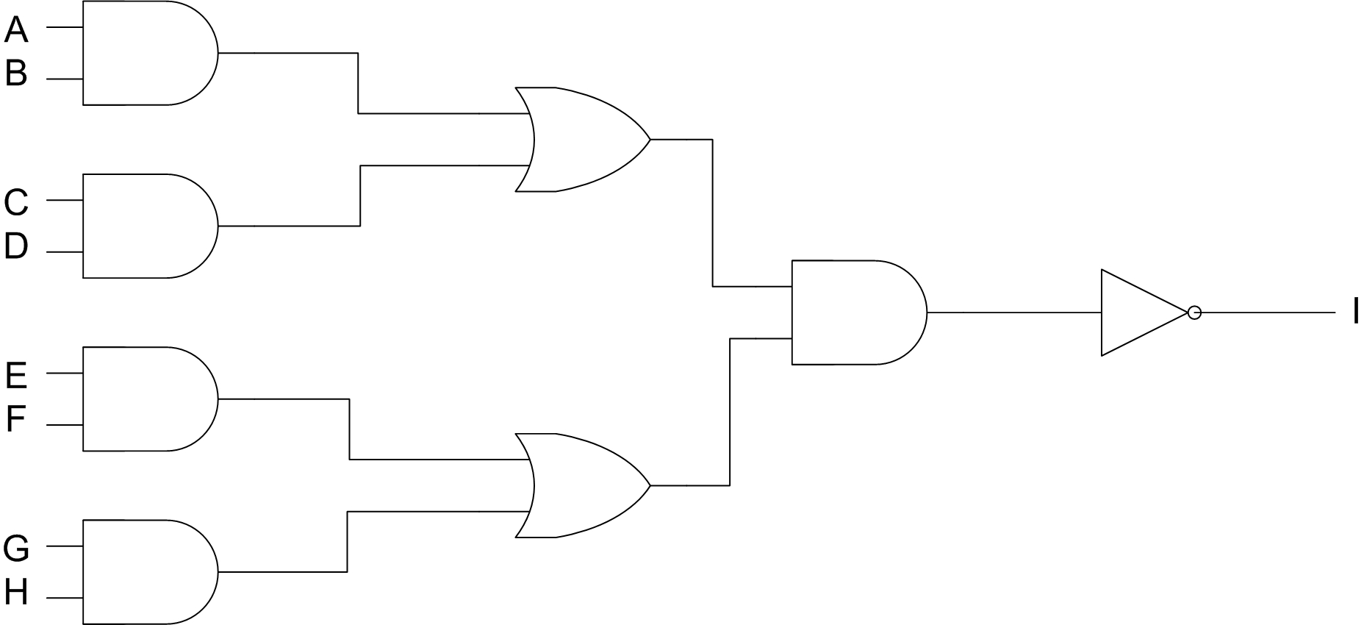

  - Suppose that a function F is composed of 4 variables {a,b,c,d}. Then conver the following expression to its canonical SOP form (sum of minterms):

F = abc + b’d + a’bc’

- [Truth table = 5 marks, KMap = 5 marks]

  - You are to create an automatic table-light switching system. Assume that there are four variables:
a = 1 if you are sitting on the arm-chair in front of your desk, 0 if not
b = 1 if you are reading a book, 0 if not
c = 1 if you are using the computer, 0 if not
d = 1 if it is day, 0 if it is night
The only conditions required to be fulfilled are:
- L = 1 (Light should be on) if:
  - You are reading a book and you are on your chair
  - If it is night and you are using the computer and you are on your chair
Note: You can still use the computer even if you are not on the chair, e.g. you might be downloading stuff. However, if you are not on your chair, we will consider it impossible that you may still be reading your book (on your desk), and hence will assume this kind of combination to be a don’t-care state.

Using 4-variable Karnaugh-Map Method, find the required SOP expression for the above specification (for L).

  - Draw the equivalent circuit for the expression found in question 4.

  - Simplify the following equation using Boolean-Algebra simplification:

( a + b ) + bc + ( a + bc )

THE END

